An alternative way of characterizing *C. elegans* movement and longevity through tracking in MATLAB

**Introduction**

Since 1963 when Sydney Brenner chose *Caenorhabditis elegans* as a model research organism in his lab, *C. elegans* has become established as one of the premiere model systems for aging and longevity research (Tissenbaum, 2015). However, most of the longevity researches performed on *C. elegans* characterized increase in worm longevity as being able to response to external stimuli such as changing oxygen levels and touch stimuli. Though these researches showed their success in increasing the longevity, or in other words lifetime able to response to external perturbations, of *C. elegans*, most of these studies failed to approve that the worms were still able to vigorously carrying out crawling and other behaviors for a longer time. It was unclarified whether the worms’ vitality was enhanced by the methods adopted in those researches. Thus, in this case, a lasting query is that whether worms, which have ceased their normal movement but live longer than the well-defined 21-day period, can be accounted as actively ‘living’.

Therefore, in order to develop another means of worm longevity characterization, we propose that the worm crawling activity can be characterized to generate a measurement of vitality. Here we were able to present that we have sought to use MATLAB to perform worm crawling movement analysis through tracking worms in videos frame by frame. We used two supplementary videos recording *C. elegans* movement from Busch et al, 2012, as samples for analysis. In these videos, worm crawling behavior was altered by the application of external light stimuli which triggers activation or inhibition of the worm AQR, PQR, and URX signaling pathways. We sought to carried out tracing of worm behavior and generated a time course of worm crawling velocity and performed statistical analysis on the time course with or without light stimulus. And we supposed that with further alternations and refinements, the code we present can be adopted as an alternative way of characterization of worm vitality characterization.

**Methods**

The MATLAB inbuilt codes utilized in this project include but are not limited to the following,

VideoReader and VideoWriter – inputting the videos of worm crawling under different light stimuli into MATLAB and generating video with the centroids of worms traced with the other parts of the code.

bwareafilt – filtering out worms in the matrices generated from videos from the background through characterization of the size of the worms. In this project, it was utilized to introduce binary masks on each frame of the videos.

MatchFrames – a well-developed function which features area tracking and trajectory analysis of two timepoints in a video of moving cells. In this project, it was used to trace the movements of worms between two consecutive pixels in the videos and generate data for further analyses.

regionprops – measuring properties of image regions. In this project, it was applied to generate the centroid coordinates, area and mean intensity of the regions characterized as worms in the binary mask.

ttest2 – conducting statistical analysis of the speed of worms on each pixel with or without light stimuli and justify whether the stimuli were able to significantly alternate the velocity of worms as suggested by Busch et al.

imfill and imdilate – filling holes in and dilating binary masks respectively. In this project, they were used in the refinement of the binary masks and the output video indicating the worms traced by the code.

**Results**

The genetically modified *C. elegans* used in the research established by Busch et al have their tonic signaling neuronal circuits AQR, PQR, and URX transfected with several components with which these neuronal circuits would be turned on through blue-light induced production of ChR2 or switched off with green-light induced production of NpHR. In this way, increasing or decreasing movements of worms can be detected after shining blue or green light respectively. We used the supplementary videos provided in their publications as models for application of our code on worm crawling behavior tracking.

As a result of our analysis, Figure.1A shows the time course of *C. elegans* movement with or without blue light stimulation, with the stimulus period depicted in red. Statistically analysis was also applied on the sets of velocities prior to, during or after the stimulus. The velocity of the worms during the blue light stimulus was characterized to be significantly different from both before and after the stimulus with *p*-values of 5.44e-21 and 2.03e-07 using a two-sample t-test. However, when we applied two-sample t-test to the sets of *C.* *elegans* crawling velocity before and after the stimulus, we still got a low *p*-value (3.35e-08) indicating that the chance of the distribution of speeds before and after the stimulus being the same was slim. We suspected that the worms were not able to completely slow down their motion during the first half of the time course after the stimulus, which can be speculated to be higher in Figure.1A, and that this is the reason for the significant difference of speed before and after the stimulus. The hypothesis was seemingly correct as when we excluded the first half of the data in the time course after the stimulus, the two sets of distribution seemed not to be significantly different from each other with a *p*-value of 0.87.

Similar analysis was performed on the other movie of *C. elegans* stimulated with green light, as shown in Figure.1B. Again, a time course of worm moving velocity was generated. In this case, as the green light stimulus reduces the speed of worm crawling through inhibition of the AQR, PQR and URX neuronal circuits, in some frames, the average speed of the worms may be calculated as NaN (not a number) as zero displacements were screened out from the mean speed calculation by the nonzero function. This time, the mean velocity distributions before and after the stimulus was not significantly different with each other (*p*-value of 0.9194), indicating that the tonic sensing neurons were not tuned on without the light stimulus. However, in this case, the mean velocity of *C. elegans* during the stimulus was not significantly different from the times without the stimulus with *p*-values of t-test of the distribution of mean velocity during the stimulus against that of the mean velocity before or after the green light stimulus being 0.7702 and 0.6592 respectively. This indicated a high chance of the difference between the mean velocity distribution with or without the light stimulus being only random but not significant. This apparently differed from what was shown in the movie (see ‘NIHMS41007-supplement-3.mov’ in GitHub repository). We suspected that the insignificance of difference between these mean velocity distributions can be attributed to the fact that a number of fast-crawling worms moved into the screen during the later part of the stimulus, drastically changing the mean velocity of the worms, which can also be seen in the time course in Figure.1B. Excluding the later part of the stimulus, the *p*-value arisen from two-sample t-test (7.03e-04) indicates that the difference between the two sets of distributions was highly unlikely to be random.

**Discussion**

In this report, we presented that we were able to generate a series of code that can take *C. elegans* crawling videos and trace the worms generate a time course of worm movement velocity. We were able to show that *C. elegans* in the stages with or without light stimuli in the movies have significantly different velocities while the application of stimuli would not significantly alter the moving patterns of the worms.

However, in the troubleshooting process, when we generated a video highlighting the worms we traced (see ‘WormLocators_20191203202420.gif’ in GitHub repository), we figured out some problems of our application of tracking codes. Firstly, the code we used was not able to separate touching worms in the videos, which were considered as a single worm and messed up with the MatchFrame code generating less targets for tracing. At the same time, some worms moving out of the central bright field but still maintained in the shaded area were considered out of the screen of tracing as they fused into an background area of similar intensities exceeding the upper threshold of worm areas defined to exclude the black areas setting the corners of the videos. We suggest that these two problems together, can be solved by using ilastik or other outside software for binary mask generation before inputting into MATLAB for analysis by MatchFrame.

One other issue was that in the velocity analysis, we only calculated the linear displacement of the centroids of the worms, which may be an inaccurate representation of worm motion. As the worms are crawling in the media, its centroid might have moved only slightly while it tumbles around, thereby rendering our calculations a misleading characterization of worm movements. Thus, a better means of worm crawling velocity calculation is desired. We propose that all the pixels of the worms can be considered in velocity calculation instead, so that the small shifting movements can be detected, generating a more accurate time course measurement of worm movement.

B

A

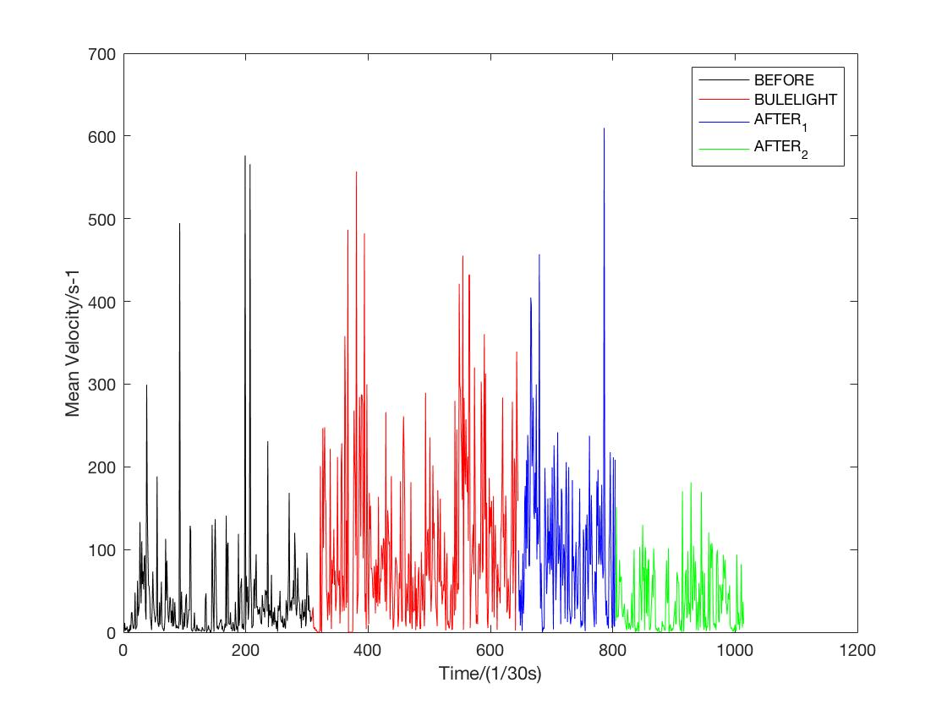Figure.1 Time courses of mean velocities of worm crawling movement stimulated with (A) blue light or (B) green light. The time periods before, during and after the stimulus were depicted as black, red and blue/green respectively.

Reference

Tissenbaum H. A. (2015). Using *C. elegans* for aging research. *Invertebr. Reprod.* **59**(sup1):59–63. doi: 10.1080/07924259.2014.940470.

Busch K. E., Laurent P., Soltesz Z., Murphy, R. J., Faivre, O., Hadwig, B., Thomas, M., Smith, H. L., de Bono, M. (2012). Tonic signaling from O₂ sensors sets neural circuit activity and behavioral state. *Nat. Neurosci.* **15**(4):581–591. doi:10.1038/nn.3061